
Център за обучение по софтуерно тестване Website: http://skillo-bg.com
Bug Template
Bug ID | Bug-001
Name | When we click in “Follow Us” Facebook button and the bottom of the page, we had a new opened windows with Crash Message.
Priority | 2
Severity | S1
Description | --------------------------
Steps to reproduce | Steps>  - Open URL: http://automationpractice.com/index.php?controller=contact .  - 2. Click on Facebook button of the bottom in the page
Attachment | 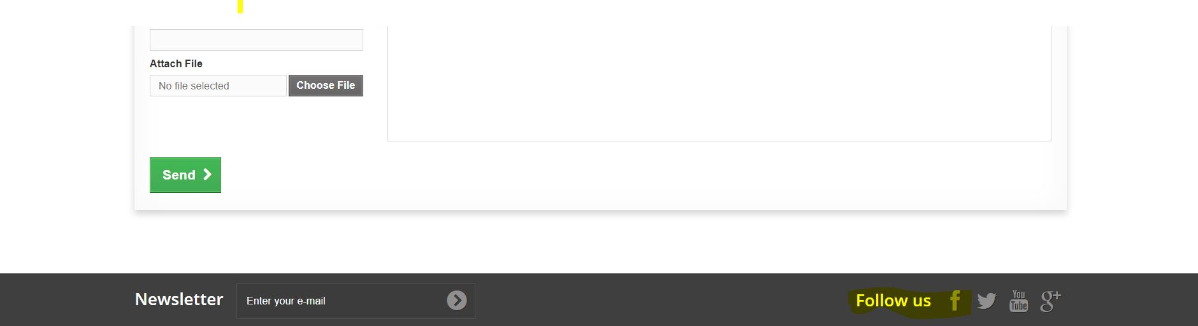
Status | -------------------------------
Component | Follow
Version/Build number (Found in) | ----------------------------
Environment | Windows 10 Pro, Google Chrome
Comments | -
Date Created | 14/02/19
Author | Plamen Debreliev
Audit Log | History of the changes for this bug

